BST
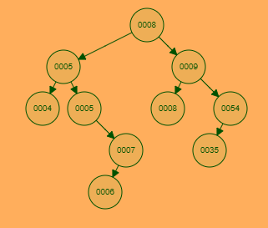
- Insertion: Insert these elements in order: 97, 24, 6, 8
  - 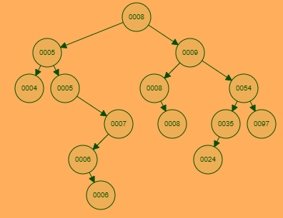
- Deletion: On this new tree, delete these elements in order: 9, 7, 54, 8(the top one)
  - 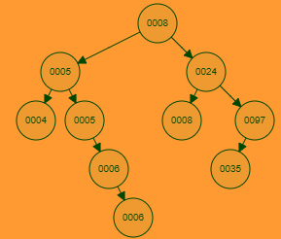
Dynamic Programming
- Dynamic programming strategy and steps;

- 0-1 Knapsack problem (how to divide into small subproblems, recursive formula, bottom up solution, table)
  - Backpack with weight capacity of 10, here is your items:
Item | Weight | Benefit
1 | 9 | 8
2 | 3 | 4
3 | 2 | 2
4 | 5 | 7
  - What is the optimal solution? (show chart and which items to add)
    - Optimal chart is:
Item\Weight | 1 | 2 | 3 | 4 | 5 | 6 | 7 | 8 | 9 | 10
1 | 0 | 0 | 0 | 0 | 0 | 0 | 0 | 0 | 8 | 8
2 | 0 | 0 | 4 | 4 | 4 | 4 | 4 | 4 | 8 | 8
3 | 0 | 2 | 4 | 4 | 6 | 6 | 6 | 10 | 12 | 12
4 | 0 | 2 | 4 | 4 | 7 | 8 | 9 | 11 | 12 | 14

    - Solution for items are: Item 5 + Item 5

  - What is the subproblem in your chart for the cell (5, 2)
    - What is the optimal solution using the first 2 items when the bag has a weight capacity of 5?

- LCS problem (how to divide into small subproblems, recursive formula, bottom-up solution, table)
- Change problem (how to divide into small subproblems, recursive formula, bottom-up solution, table)
- How to apply dynamic programming ideas to solve new problems.

Greedy Programming:
- Greedy Programming strategy, property, why the optimal solution is not guaranteed.
- Compare greedy programming and dynamic programming.
- Fractional knapsack problem
  - Backpack with weight capacity of 10, here is your items:
Item | Weight | Benefit
1 | 9 | 8
2 | 3 | 4
3 | 2 | 2
4 | 5 | 7
  - What is the greedy solution? (assume 1 of each item, yes optimal would be different than before)
    - Benefit weight ratios:
    - Item 1: 8/9 = <1
    - Item 2: 4/3 = 1.33
    - Item 3: 2/2 = 1
    - Item 4: 7/5 = 1.4
    - Adding most beneficial (by ratio):
      - + All of Item 4
        - 10 – 5 = 5
      - + All of Item 2
        - 5 – 3 = 2
      - + All of Item 3
        - 2 – 2 = 0
    - Total benefit would be: 7 + 4 + 2 = 13

- Why can Huffman coding compress data?
- Huffman coding, Huffman tree, compression ratio, decoding
  - Make a Huffman code off of this: aaaaaaaaabcdbdbdbabba
    - 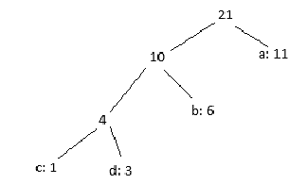
  - Decode this: 000101001101
    - cabdab
Graph:
- Terminologies (directed, undirected, weighted, unweighted, loop, simple graph, complete graph, parallel edges, subgraph, cycle)
- Graph Representation (adjacency list, adjacency matrix), time complexity, compare two representations (pros and cons)
- Graph Search (BFS, DFS)
  - 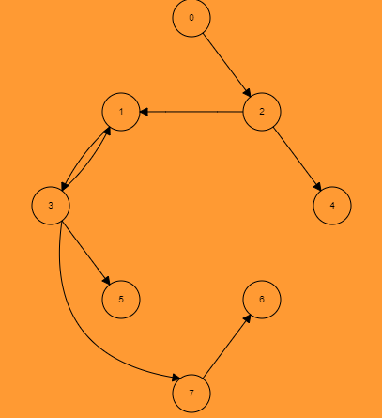-
  - BFS, go!
    - Imagine I’m enqueuing and dequeuing really fast and the steps actually make sense.
    - empty
    - 0
    - 2
    - 1, 4
    - 4, 3
    - 3
    - 5, 7
    - 7
    - 6
    - Empty
  - DFS on same graph, go!
    - The chart is here:
 | 0 | 1 | 2 | 3 | 4 | 5 | 6 | 7
S | 1 | 3 | 2 | 4 | 13 | 5 | 8 | 7
E | 16 | 12 | 15 | 11 | 14 | 6 | 9 | 10

  - Don’t have to name the edges cuz im nice…but u could if u wanted

- Applications of BFS and DFS
- Minimum Spanning Tree Definition,
- Kruskal’s algorithm, Prim’s Algorithm, time complexity
  - 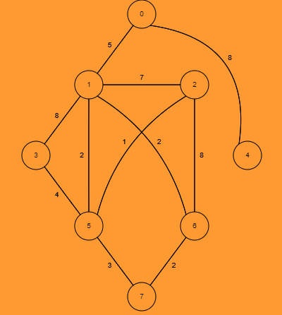
  - Kruskal’s, go!
    - 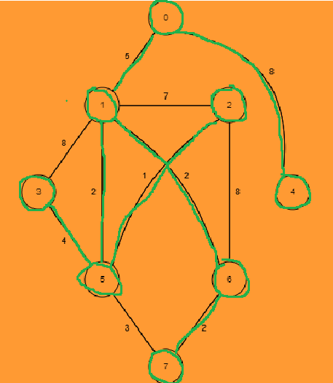
    - Rly, more importantly is the order:
    - 5 – 2 (1)
    - 1 – 5 (2)
    - 1 – 6 (2)
    - 6 – 7 (2)
    - 5 – 3 (4)
    - 1 – 0 (5)
    - 0 – 4 (8)

  - Prim’s, go! (start at 0)
    - Again, more important is the order (also, it’s the same min graph):
    - 0 – 1 (5)
    - 1 – 5 (2)
    - 5 – 2 (1)
    - 1 – 6 (6)
    - 6 – 7 (2)
    - 5 – 3 (4)
    - 0 – 4 (8)

- Single-Source Shortest Path definition, negative edges;
- Bellman-Ford Algorithm, Dijkstra’s Algorithm, time complexity;
  - 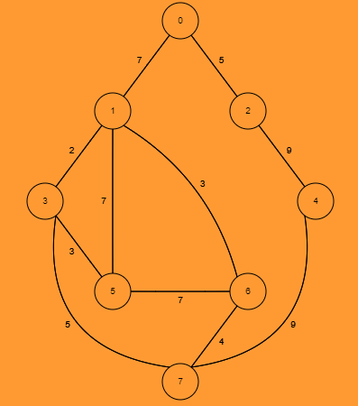
  - Dijkstra, go! (Start @ 0)
    - 0th step:
 | 0 | 1 | 2 | 3 | 4 | 5 | 6 | 7
Cost | 0 | ∞ | ∞ | ∞ | ∞ | ∞ | ∞ | ∞
Parent | -1

    - 1st step:
 | 0 | 1 | 2 | 3 | 4 | 5 | 6 | 7
Cost | 0 | 7 | 5 | ∞ | ∞ | ∞ | ∞ | ∞
Parent | -1 | 0 | 0

    - 2nd step:
 | 0 | 1 | 2 | 3 | 4 | 5 | 6 | 7
Cost | 0 | 7 | 5 | ∞ | 14 | ∞ | ∞ | ∞
Parent | -1 | 0 | 0 |  | 2

    - 3rd step:
 | 0 | 1 | 2 | 3 | 4 | 5 | 6 | 7
Cost | 0 | 7 | 5 | 9 | 14 | 14 | 10 | ∞
Parent | -1 | 0 | 0 | 1 | 2 | 1 | 1

    - 4th step:
 | 0 | 1 | 2 | 3 | 4 | 5 | 6 | 7
Cost | 0 | 7 | 5 | 9 | 14 | 12 | 10 | 14
Parent | -1 | 0 | 0 | 1 | 2 | 3 | 1 | 3

    - 5th step:
 | 0 | 1 | 2 | 3 | 4 | 5 | 6 | 7
Cost | 0 | 7 | 5 | 9 | 14 | 12 | 10 | 14
Parent | -1 | 0 | 0 | 1 | 2 | 3 | 1 | 3

    - 6th step:
 | 0 | 1 | 2 | 3 | 4 | 5 | 6 | 7
Cost | 0 | 7 | 5 | 9 | 14 | 12 | 10 | 14
Parent | -1 | 0 | 0 | 1 | 2 | 3 | 1 | 3
      - On this step it doesn’t matter if u pick 4 or 7, I just went in increasing order
    - 7th step:
 | 0 | 1 | 2 | 3 | 4 | 5 | 6 | 7
Cost | 0 | 7 | 5 | 9 | 14 | 12 | 10 | 14
Parent | -1 | 0 | 0 | 1 | 2 | 3 | 1 | 3

  - 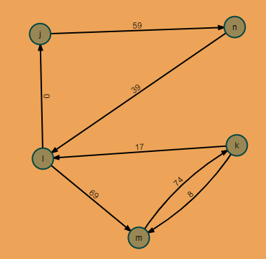
  - Belleman Ford on 3rd cycle alone, go! (l is start, order of cycle is: (k, l), (m, k), (l, m), (k, m), (n, l), (j, n), (l, j))
    - 0th cycle chart:
J | K | L | N | M
∞ | ∞ | 0 | ∞ | ∞

    - 1st cycle chart:
J | K | L | N | M
0 | ∞ | 0 | ∞ | 69

    - 2nd cycle chart:
J | K | L | N | M
0 | 143 | 0 | 59 | 69

    - 3rd cycle chart:
J | K | L | N | M
0 | 143 | 0 | 59 | 69

- All-pairs Shortest Path definition, Floyd-Warshall Algorithm (idea, recursive formula, subproblems)
  - 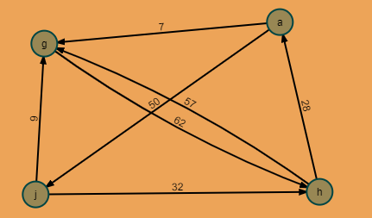
  - Floyd-Warshall, go! (assume 1 = a, g = 2, h = 3, j = 4 for your D#)
    - D0:
 | a | g | h | j
a | 0 | 7 | ∞ | 50
g | ∞ | 0 | 62 | ∞
h | 28 | 57 | 0 | ∞
j | ∞ | 9 | 32 | 0

P0:
 | a | g | h | j
a | NIL | a | NIL | a
g | NIL | NIL | g | NIL
h | h | h | NIL | NIL
j | NIL | j | j | NIL

    - D1:
 | a | g | h | j
a | 0 | 7 | ∞ | 50
g | ∞ | 0 | 62 | ∞
h | 28 | 35 | 0 | 78
j | ∞ | 9 | 32 | 0

P1:
 | a | g | h | j
a | NIL | a | NIL | a
g | NIL | NIL | g | NIL
h | h | a | NIL | a
j | NIL | j | j | NIL

    - D2:
 | a | g | h | j
a | 0 | 7 | 69 | 50
g | ∞ | 0 | 62 | ∞
h | 28 | 35 | 0 | 78
j | ∞ | 9 | 32 | 0

P2:
 | a | g | h | j
a | NIL | a | g | a
g | NIL | NIL | g | NIL
h | h | a | NIL | a
j | NIL | j | j | NIL

    - D3:
 | a | g | h | j
a | 0 | 7 | 69 | 50
g | 90 | 0 | 62 | 140
h | 28 | 35 | 0 | 78
j | 60 | 9 | 32 | 0

P3:
 | a | g | h | j
a | NIL | a | g | a
g | h | NIL | g | h
h | h | a | NIL | a
j | h | j | j | NIL

    - D4:
 | a | g | h | j
a | 0 | 7 | 69 | 50
g | 90 | 0 | 62 | 140
h | 28 | 35 | 0 | 78
j | 60 | 9 | 32 | 0

P3:
 | a | g | h | j
a | NIL | a | g | a
g | h | NIL | g | h
h | h | a | NIL | a
j | h | j | j | NIL

- Make sure you understand all examples we learned.

